STUDENT MESSENGER
Submitted to DATABASE MANAGEMENT SYSTEMS LAB
BY

B.HARIBABU G.SRI SUMANTH RegNo:680755030 RegNo:680755027
K.DINESH G.RAGHU MANIKANTA
RegNo:680755021 RegNo:680755029
B.GOVIND RAO B.RAJENDRA PRASAD
Reg.No:680755013 RegNo:680755012
P.BALA CHAITANYA
RegNo:680755011

Under the guidance of
MR. B.SRINIVAS RAO B.TECH
MR.B.DEVENA RAJU M.TECH
Smt.A.SUNITHA M.TECH
Ms.G.SATYAVANI B.TECH


DEPARTMENT OF COMPUTER SCIENCE AND ENGINEERING
SIR CRR COLLEGE OF ENGINEERING
(accredited by NBA)
(affiliated to ANDHRA UNIVERSITY)

SIR CR REDDY COLLEGE OF ENGINEERING
(Affiliated to ANDHRA UNIVERSITY)
ELURU
BONAFIDE CERTIFICATE
This is to certify that the mini project titled “STUDENT MESSENGER” has been successfully completed by the following students.

B.HARIBABU G.SRI SUMANTH
RegNo:680755030 RegNo:680755027
K.DINESH G.RAGHU MANIKANTA
RegNo:680755021 RegNo:680755029
B.GOVIND RAO B.RAJENDRA PRASAD
RegNo:680755013 RegNo:680755012
P.BALA CHAITANYA
RegNo:680755011

This work has been carried during the academic year 2009-2010 for database management systems lab in III/IV second semester B.Tech COMPUTER SCIENCE AND ENGINEERING.

PROJECT GUIDE HEAD OF THE DEPT
(Signature) (Signature)

CONTENTS

Page no.
Abstract 4
- INTRODUCTION 5 - 9
  - Problem Specification
  - Problem Related Description Of The Organization
  - Operational Structure
- BACKGROUND INFORMATION 10 - 28
2.1. HTML
2.2. DBMS
2.3. MYSQL
2.4. PHP
3. SYSTEM ANALYSIS 29 - 32
3.1. Existing System
3.2. Proposed System
3.3. Feasibility Study
3.4. Requirement Specification
4. SYSTEM DESIGN 33 - 37
4.1. ER-DIAGRAM
4.2. TABLES
5. CODES 38 - 83
5.1. HTML
5.2. PHP
6. FORMS 84 - 91
7. REPORTS 92 - 99
8. CONCLUSION 100
9. BIBLIOGRAPHY 101

ABSTRACT

Communication between people from various places has become too easy due to the advancement of internet. But not in many educational institutions, there is a communication medium for students.

Our project deals with the communication within a local area network. It provides mail sending, chatting and forums (any user can view and answer to a forum). It contains two varieties of accounts – user & administrator. A user can communicate & share ideas with other users using any local system connected to the server. There exists only one administrator who controls all the users.

The project uses HTML as front end & MYSQL as back end. The connectivity is provided by PHP.

INTRODUCTION

1.1 PROBLEM SPECIFICATION:

The project “STUDENT MESSENGER” aims at communication within a local area network. It provides facility for students in an organization to interact and share ideas. This project makes two persons anywhere within the campus communicate from any local system connected to the server. It also deals with maintanence of discipline of the communication.

The following are the main facilities offered by the system:
- Generating list of users registered.
- Registration of new users.
- Sending and receiving mails.
- Online chat between users.
- Maintaining personal contacts.
- Posting a question in forums by users.
- Viewing and answering the posts in forums.
- Deleting users by administrator.
1.2. PROBLEM DESCRIPTION OF THE ORGANISATION
Not in many educational institutions, there is a communication medium for students. Our project is a solution for this problem. So, students can always communicate with each other using this system for free of cost instead of wasting money for mobile bills.

The following are the benefits provided by the system:
- Saves more time.
- Students can exchange their views using forums.
- Can stay in touch with friends.
- Provides security by giving permissions separately to administrator and user.
- Any user can easily access the forums questions and answers.
- The users can be deleted by the administrator if an user is offensive.
- Provides communication discipline.

1.3 OPERATIONAL STRUCTURE:

The general methodology in developing a system is involved in different phases, which describe the systems life cycle model for developing software project. The concept includes not only forward motion but also have the possibility to return that is cycle back to an activity previously completed. This cycle back or feedback may occur as a result of the failure with the system to meet a performance objective or as a result of changes in redefinition of system activities. Like most systems, the life cycle of the computer based system also exhibits distinct phases.
Those are,
- Requirement Analysis Phase
- Design Phase
- Development Phase
- Coding Phase
- Testing Phase

REQUIREMENT ANALYSIS PHASE:

This phase includes the identification of the problem, in order to identify the problem; we have to know information about the problem, the purpose of the evaluation for problem to be known. We have to clearly know about the client’s requirements and the objectives of the project.

SYSTEM ANALYSIS PHASE:

Feasibility analysis involves the benefits of various approaches and the determination of the alternative approaches all through methods like questionnaires and interviews etc., different data about the project are collected and the data through out the project is represented in the graphical form.

DESIGN PHASE:
Software design is a process through which the requirements are translated into a representation of software(s/w). One of the software requirements have been analyzes and specifies, the s/w design involves three technical activities: design, code generation and testing. The design of the system is in modular form i.e., the s/w is logically partitioned into components that perform specific functions and sub functions. The design phase leads to modules that exhibit independent functional characteristics. It even leads to an interface that reduces the complexity of the connections between modules and with the external environment. The design phase of main importance because in this activity, decisions ultimately affect the success of s/w implementation and maintenance.

DEVELOPMENT PHASE:

The development phase includes choosing of a suitable s/w to solve the particular problem given. The various facilities and the sophistication in the selected s/w give a better development of the problem.

CODING PHASE:

The coding phase is for translating the design of the system produced during the design phase into code in a programming language, which can be executed by a computer and which performs the computation specified by the user.

TESTING PHASE:

Testing is done in various ways such as testing the algorithm, programming code, simple data debugging is also one of the testing methodology.

SCOPE:

- Session Management was implemented to avoid the authorized access to users.
- All the authorized administrators and users can access the information from any local system.
- The details of all the students are maintained perfectly.
- Updating the student details is performed perfectly. Once done it effects the data in all the modules.

OBJECTIVE:

The main objective of this project is to provide communication within an organisation. It provides facility for students in an organization to interact and share ideas. This project makes two persons anywhere within the campus communicate from any local system connected to the server. Keeping in mind that students’ interaction can make the students bright and strong in circular and other activities, we developed this software STUDENT MESSENGER.

HTML

What is an HTML File?
- HTML stands for Hyper Text Markup Language
- Hyper text is ordinary text that has been dressed up with features such as formatting, images, multimedia and links to other documents.
- Markup is the process of taking ordinary text and adding extra symbols.
- An HTML file is a text file containing small markup tags
- The markup tags tell the Web browser how to display the page
- An HTML file must have an .htm or .html file extension
- An HTML file can be created using a simple text editor

AN EXAMPLE OF HTML:
If you are running Windows, start Notepad and type in the following text:
<html>
<head>
<title>Title of page</title>
</head>
<body>
This is my first homepage. <b>This text is bold</b>
</body>
</html>

Start your Internet browser. Select "Open" (or "Open Page") in the File menu of your browser. A dialog box will appear. Select "Browse" (or "Choose File") and locate the HTML file you just created - "mypage.htm" - select it and click "Open". Now you should see an address in the dialog box, for example "C:\MyDocuments\mypage.htm". Click OK, and the browser will display the page.

Example Explained:
The first tag in your HTML document is <html>. This tag tells your browser that this is the start of an HTML document. The last tag in your document is </html>. This tag tells your browser that this is the end of the HTML document.
The text between the <head> tag and the </head> tag is header information. Header information is not displayed in the browser window.
The text between the <title> tags is the title of your document. The title is displayed in your browser's caption.
The text between the <body> tags is the text that will be displayed in your browser.
The text between the <b> and </b> tags will be displayed in a bold font.

HTML Tags:
- HTML tags are used to mark-up HTML elements
- HTML tags are surrounded by the two characters < and >
- The surrounding characters are called angle brackets
- HTML tags normally come in pairs like <b> and </b>
- The first tag in a pair is the start tag, the second tag is the end tag
- The text between the start and end tags is the element content
- HTML tags are not case sensitive, <b> means the same as <B>

HTML Elements:

This is an HTML element:
<b>This text is bold</b>.
The HTML element starts with a start tag: <b>
The content of the HTML element is: This text is bold
The HTML element ends with an end tag: </b>.
The purpose of the <b> tag is to define an HTML element that should be displayed as bold.

HTML Tag Attributes:

- HTML tags can have attributes.
- Attributes provide additional information to an HTML element.
- Attributes always come in name/value pairs like this: name="value".
- <body>: This tag defines the body of an HTML document.<body bgcolor="yellow"> has additional information about the background color.
- <table>: This tag defines an HTML table. (You will learn more about HTML tables later)
- <table border="1"> has additional information about the border around the table
- Attributes are always specified in the start tag of an HTML element.

HTML Advantages:
- HTML is the primary format used on the World Wide Web.
- HTML can display Web pages with a wide range of colors, shapes, and objects.
- HTML is so flexible, many browsers and Web applications have added their own functionality to the base HTML protocol.
- HTML ensures consistency in style across elements that have the same meaning.

DATABASE MANAGEMENT SYSTEM

DATABASE:

A database is a collection of data, with some internal meaning design built populated with data for a specific purpose.

CHARACTERISTICS:

- Represents complex relationship between data.
- Keeps control on data redundancy.
- Enforces data access authorization.
- Has automatic intelligent backup and recovery procedure for data.
- Keeps a centralized data dictionary for the storage of information pertaining to data and manipulation.

DATA MODELS:

The structure of the database is the conceptual model, collection of tools for describing data relationship, semantics and consistency constrains.

- Object Based models
Object-based logical model are used in describing at the conceptual and view levels there are two of object-based models:

i. The entity relationship model: this model is model based on a Real world, which consists of a collection of objects called entities and relationship among these.

ii. The object Oriented model: The Object oriented model is based on the collection of objects. Methods are grouping into classes a class may be viewed as a type definition-for-objects.

II. Records based Models:

Record based models are so named because the data is structured in fixed format records. The three most accepted record based data models are relation, network, and hierarchical models.

i. Relation Model: The Relational represents the data and relational ship among data by a collection of tables, where each table has a number of columns with unique names.

ii. Network model: Data in network model are represented by collection of records and relationships among data are represented by links, which can be viewed as pointers. The records in the database are organized as collection of arbitrary graphs.

iii. Hierarchical Model: This model is similar to network model in the sense that data and relationships among data represented by records and links, respectively. It differs from the network model in that the records are organized as collection of trees rather than arbitrary graphs.

RELATIONAL DATABASE MODEL:

A Relational database consists of collection of the tables, each of which is assigned unique name. Each table contains number of columns also with unique names. Relational is an association among several entities. The row in a table represents a relation ship among a set of values.

TABLES:

In relational system data is organized and presented in tables. Tables are simply a collection of related rows and columns.

ROWS:

Rows are the horizontal components of a table. They are unnamed and unordered. This means that there is no way to specify a particular table rows by its position in a table are accessed by data values only.

COLUMNS:

Columns are the vertical components of table. Unlike rows, columns are named and ordered. Every table columns has a unique name within the table and add a data attributes for it.

FIELDS:

Fields refer to the specific data values stored in a table for a particular intersection of row and column. A field is the smallest unit of data in SQL. A null field denotes absence of data values for that particular field.

ADVANTAGES OF RDMS:

1. Redundancy can be reduced: In a non-database system, each application has its own private file. This often leads to considerable redundancy in stored data with result wastage in storage space.

2. Inconsistency can be avoided: There will be some occasions on which two entries do not agree. This is called inconsistency. It can be avoided in a database by propagation updates.

3. Data can be shared: It means that not only the existing application can share the data in a database but also new applications can be developed.

4. Standards can be enforced: With central control of data, certain standards like Industrial, National, and international can be developed.

5. Security Restrictions can be applied: Having complete control of data, we can ensure that the only means of accessing data is through proper channel.

6. Integrity can be maintained: The problem of integrity is the problem of ensuring data in the database is accurate. It can be ensured that by definition validation procedures whenever updating operation is to be carried out.

7. Conflicting requirements can be balanced: Database can be structured to provide an over-all service.

MYSQL

What is MySQL?
MySQL, the most popular Open Source SQL database management system, is developed, distributed, and supported by MySQL AB.
- MySQL is a database management system.
A database is a structured collection of data. It may be anything from a simple shopping list to a picture gallery or the vast amounts of information in a corporate network. To add, access, and process data stored in a computer database, you need a database management system such as MySQL Server. Since computers are very good at handling large amounts of data, database management systems play a central role in computing, as standalone utilities, or as parts of other applications.
- MySQL is a relational database management system.
A relational database stores data in separate tables rather than putting all the data in one big storeroom. This adds speed and flexibility. The SQL part of “MySQL” stands for “Structured Query Language.” SQL is the most common standardized language used to access databases and is defined by the ANSI/ISO SQL Standard.
- MySQL software is Open Source.
Open Source means that it is possible for anyone to use and modify the software. Anybody can download the MySQL software from the Internet and use it without paying anything. If you wish, you may study the source code and change it to suit your needs.

- The MySQL Database Server is very fast, reliable, and easy to use.
MySQL Server was originally developed to handle large databases much faster than existing solutions and has been successfully used in highly demanding production environments for several years.
- MySQL Server works in client/server or embedded systems.
The MySQL Database Software is a client/server system that consists of a multi-threaded SQL server that supports different back ends. We also provide MySQL Server as an embedded multi-threaded library that you can link into your application to get a smaller, faster, easier-to-manage standalone product.

The Main Features of MySQL:
- Written in C and C++.
- Tested with a broad range of different compilers.
- Works on many different platforms.
- The MySQL Server design is multi-layered with independent modules.
- Fully multi-threaded using kernel threads. It can easily use multiple CPUs if they are available.
- Relatively easy to add other storage engines. This is useful if you want to provide an SQL interface for an in-house database.
- A very fast thread-based memory allocation system.
- In-memory hash tables, which are used as temporary tables.
- The MySQL code is tested with Purify (a commercial memory leakage detector).
- The server is available as a separate program for use in a client/server networked environment. It is also available as a library that can be embedded (linked) into standalone applications. Such applications can be used in isolation or in environments where no network is available.

Distinguishing features:

The following features are implemented by MySQL but not by some other RDBMSes:
- Multiple storage engines, allowing you to choose the one which is most effective for each table in the application (in MySQL 5.0, storage engines must be compiled in. In MySQL 5.1, storage engines can be dynamically loaded at Run time.
- Native storage engines (MyISAM, Falcon, Merge, Memory (heap), Federated, Archive, CSV, Blackhole, Cluster, BDB, EXAMPLE)
- Partner-developed storage engines (InnoDB, solidDB, NitroEDB, BrightHouse)
- Community-developed storage engines (memcached, httpd, PBXT)
DATATYPES:
- Many data types: signed/unsigned integers 1, 2, 3, 4, and 8 bytes long, FLOAT, DOUBLE, CHAR, VARCHAR, TEXT, BLOB, DATE, TIME, DATETIME, TIMESTAMP, YEAR, SET, ENUM.
STATEMENTS AND FUNCTIONS:
- Full operator and function support in the SELECT list and WHERE clause of queries.
- For example:
- mysql> SELECT CONCAT(first_name, ' ', last_name)
- -> FROM citizen
- -> WHERE income/dependents > 10000 AND age > 30;
- Full support for SQL GROUP BY and ORDER BY clauses. Support for group functions (COUNT(), COUNT(DISTINCT ...), AVG(), STD(), SUM(), MAX(), MIN(), and GROUP_CONCAT()).
- Support for LEFT OUTER JOIN and RIGHT OUTER JOIN with both standard SQL and ODBC syntax.
- DELETE, INSERT, REPLACE, and UPDATE return the number of rows that were changed (affected). It is possible to return the number of rows matched instead by setting a flag when connecting to the server.
- The MySQL-specific SHOW statement can be used to retrieve information about databases, storage engines, tables, and indexes.
- The EXPLAIN statement can be used to determine how the optimizer resolves a query.
SECURITY:
- A privilege and password system that is very flexible and secure, and that allows host-based verification.
- Passwords are secure because all password traffic is encrypted when you connect to a server.
SCALABILITY AND LIMITS:
- Handles large databases. We use MySQL Server with databases that contain 50 million records. We also know of users who use MySQL Server with 60,000 tables and about 5,000,000,000 rows.
CONNECTIVITY:
- Clients can connect to MySQL Server using several protocols:
  - Clients can connect using TCP/IP sockets on any platform.
  - On UNIX systems, clients can connect using UNIX domain socket files.
- MySQL client programs can be written in many languages. A client library written in C is available for clients written in C or C++, or for any language that provides C bindings.
- APIs for C, C++, Eiffel, Java, Perl, PHP, Python, Ruby, and Tcl are available, allowing MySQL clients to be written in many languages.
- The Connector/ODBC (MyODBC) interface provides MySQL support for client programs that use ODBC (Open Database Connectivity) connections. The Connector/J interface provides MySQL support for Java client programs that use JDBC connections. Clients can be run on Windows or UNIX. Connector/J source is available.
MySQL Connector/NET enables developers to easily create .NET applications that require secure, high-performance data connectivity with MySQL aware tools. Developers can build applications using their choice of .NET languages.

WHY MYSQL?
- The MySQL® database has become the world's most popular open source database because of its consistent fast performance, high reliability and ease of use. It's used on every continent (even Antarctica!) by individual Web developers as well as many of the world's largest and fastest-growing organizations to save time and money powering their high-volume Web sites, business-critical systems and packaged software -- including industry leaders such as Yahoo!, Alcatel-Lucent, Google, Nokia, YouTube, and Zappos.com.
- Not only is MySQL the world's most popular open source database, it's also become the database of choice for a new generation of applications built on the LAMP stack (Linux, Apache, MySQL, PHP / Perl / Python.) MySQL runs on more than 20 platforms including Linux, Windows, OS/X, HP-UX, AIX, Netware, giving you the kind of flexibility that puts you in control.
- Whether you're new to database technology or an experienced developer or DBA, MySQL offers a comprehensive range of certified software, support, training and consulting to make you successful.

PHP

What is PHP?
- PHP stands for PHP: Hypertext Preprocessor
- PHP is a server-side scripting language, like ASP
- PHP scripts are executed on the server
- PHP supports many databases (MySQL, Informix, Oracle, Sybase, Solid, Generic ODBC, etc.)
- PHP is an open source software (OSS)
- PHP is free to download and use
- PHP is a reflective programming language originally designed for producing dynamic web pages.

What is a PHP File?
- PHP files may contain text, HTML tags and scripts
- PHP files are returned to the browser as plain HTML
- PHP files have a file extension of ".php", ".php3", or ".phtml"

Why PHP?
- PHP runs on different platforms (Windows, Linux, Unix, etc.)
- PHP is compatible with almost all servers used today (Apache, IIS, etc.)
- PHP is FREE to download from the official PHP resource: www.php.net
- PHP is easy to learn and runs efficiently on the server side.

Features of PHP:
- Robust support for object oriented programming
- The php data objects extension, which defines a lightweight and consistent interface for accessing databases.
- Better support for mysql through a completely rewritten extension.
- Error handling through exception

Sample PHP Code:
Copy the code paste it on you account, and save it as info.php4.

<?php

Phpinfo();

?>

It will output information about the current state of PHP, which information of PHP compilation options and extensions, the PHP version, server information and environment, the PHP environment, OS version information, paths, master and local values of configuration options, HTTP headers, and the PHP license.

Comments in PHP:
In PHP, we use // to make a single-line comment or /* and */ to make a large comment block.
<html>
<body>
<?php
//This is a comment
/*
This is
a comment
block
*/
?>
</body>
</html>

PHP as Server-side scripting:

Server-side scripting is a web server technology in which a user's request is fulfilled by running a script directly on the web server to generate dynamic HTML pages. It is usually used to provide interactive web sites that interface to databases or other data stores. This is different from client-side scripting where scripts are run by the viewing web browser, usually in JavaScript.

The primary advantage to server-side scripting is the ability to highly customize the response based on the user's requirements, access rights, or queries into data stores.

Basic PHP Syntax:
A PHP scripting block always starts with <?php and ends with ?>. A PHP scripting block can be placed anywhere in the document.
A PHP file normally contains HTML tags, just like an HTML file, and some PHP scripting code.
Below, we have an example of a simple PHP script which sends the text "Hello World" to the browser:
<html>
<body>
<?php
echo "Hello World";
?>
</body>
</html>
Each code line in PHP must end with a semicolon. The semicolon is a separator and is used to distinguish one set of instructions from another.
There are two basic statements to output text with PHP: echo and print. In the example above we have used the echo statement to output the text "Hello World".

Variables in PHP:
- Variables are used for storing a values, like text strings, numbers or arrays.
- When a variable is set it can be used over and over again in your script
- All variables in PHP start with a $ sign symbol.
- The correct way of setting a variable in PHP: $var_name=value
DATATYPES:

PHP stores whole numbers in a platform-dependent range. This range is typically that of 32-bit signed integers. Integer variables can be assigned using decimal (positive and negative), octal and hexadecimal notations. Real numbers are also stored in a platform-specific range.
PHP has a native Boolean type, named "boolean", similar to the native Boolean types in Java and C++. Using the Boolean type conversion rules, non-zero values are interpreted as true and zero as false, as in Perl.

There are eight data types in PHP:
- Integer
- Double
- Boolean
- String
- Object
- Array
- Null
- Resource
The null data type represents a variable that has no value. The only value in the null data type is NULL.

Resources:

Libraries:
PHP includes a large number of free and open source libraries with the core build. PHP is a fundamentally Internet-aware system with modules built in for accessing FTP servers, many database servers, embedded SQL libraries such as embedded MySQL and SQLite, LDAP servers, and others. Many functions familiar to C programmers such as those in the ‘stdio’ family are available in the standard PHP build.

Extension:
PHP allows developers to write extensions in ‘C’ to add functionality to the PHP language. These can then be compiled into PHP or loaded dynamically at runtime.

Debuggers and profilers:
Debuggers and profilers allow developers to analyze running PHP code for potential and noted software bugs and bottlenecks. Examples of such software for PHP include APD and Xdebug.

The Advantages of PHP:

- PHP is one of the most popular server side scripting languages running today. It is used for creating dynamic webpages that interact with the user offering customized information.
- PHP offers many advantages; it is fast, stable, secure, easy to use and open source (free).

APACHE:

Apache is the most popular web server on the internet. Apache is an open source project like LINUX, MySQL and PHP. Apache is based on the NCSA (National Center for Super Computing Applications) web server.

In 1995-1996 a group of developers coalesced around a collection of patches to the original NCSA web server. This group evolved into the Apache has become a robust well documented multi-threaded web server. Particularly appealing in the 2.0 release improved support for non-UNIX systems.

Apache can run on a large number of hardware and software platforms. Since 1996 Apaches has been most popular web server on the internet. Presently apache holds 67% of the market.

3.Analysis

EXISTING SYSTEM:

The information about the student details and the account transactions are maintained manually and there is no security for data being preserved. There is chance of modifying the existing information without any authentication. Manual work is more and very time consuming and involves bugs depending on the status of the person.

DEMERITS OF EXISTING SYSTEM:

- Existing system needs mobile communication which is expensive.
- Existing system doesnot support automation.
- Large information is difficult to send in existing system.
- Mail sending is not possible with mobile communication.
- The existing system doesn’t support for authenticated modification of data.

PROPOSED SYSTEM:

In this system we are automating all the manual work for faster access of data. We are utilizing the latest technology by making access simpler. It involves the automation in the following modules.

      - Student
      - Communication
      - Permissions
      - Online chat
      - Forums
      - Lists of users

MERITS OF AUTOMATION:

- Redundancy of the data is much more reduced.
- Fastness in getting the details.
- Efficient and effective.
- Information retrieval is fast.
- Authenticated modification of data is allowed.

Feasibility study:
Feasibility consideration:
The following feasibilities are considered for project inorder to ensure that the project is viable and does not have any major obstructions. In this regard technical, operational feasibilities are analyzed.

Technical Feasibility:
The technical feasibility centers around the existing computer system (Hardware, Software) and to what extent it can support the proposed system that is does the organization have the technology and the skills necessary to carry out the project and if not how should these obtained.
The project requires softwares HTML, PHP, MySQL.
Behaviorial Feasibility:
People are inherently resistant to change and computers have known to facilitate the change. Also computerization and automation reduces a great deal of manual work. Hence this system will be welcomed and readily accepted by the staff of the hostel.

REQUIREMENTS SPECIFICATION

SOFTWARE REQUIREMENTS:

- Operating system : WINDOWS XP or RED HAT or LINUX
- Connectivity : PHP
- Data base : MYSQL
- Webbrowser : MOZILLA or IE
- Front end : HTML

HARDWARE REQUIREMENTS:

- Processor : PENTIUM-IV & above.
- RAM : 256MB & above.
- Hard Disk : 20GB & above.
- Monitor

DESIGN CONSTRAINTS

- Administrator is given username and password.
- Existing database changes permission given only for administrator.
- All the users are given permission for superficial access of their own data.
- The data about each student should be consistent without any redundancy and can be accessed by the administrator.

ER-DIAGRAM
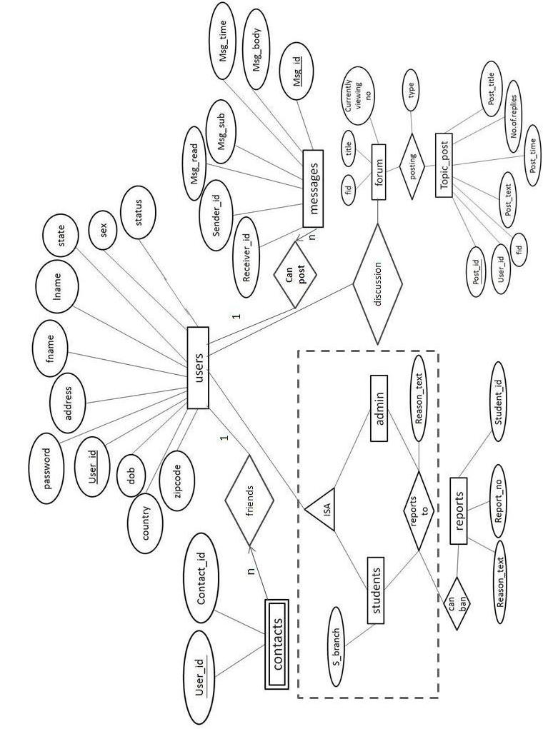
TABLES

CREATE TABLE USERS(
USER_ID VARCHAR(15) NOT NULL,
PASSWORD VARCHAR(15) NOT NULL,
FNAME VARCHAR(15) NOT NULL,
LNAME VARCHAR(15) NOT NULL,
ADDRESS VARCHAR(30),
STATE VARCHAR(20),
COUNTRY VARCHAR(20),
ZIPCODE INTEGER DEFAULT 0,
S_BRANCH VARCHAR(5) NOT NULL,
SEX VARCHAR(6) NOT NULL,
DOB DATE NOT NULL,
STATUS INTEGER DEFAULT 0,
PRIMARY KEY (USER_ID));

CREATE TABLE ADMIN(
USERNAME VARCHAR(15) NOT NULL,
PASSWORD VARCHAR(15) NOT NULL,
PRIMARY KEY(USERNAME));

CREATE TABLE CONTACTS(
USER_ID VARCHAR(15),
CONTACT_ID VARCHAR(15));

CREATE TABLE CONTACTS(
MSG_ID INTEGER AUTOINCREMENT,
RECEIVER_ID VARCHAR(15) NOT NULL,
SENDER_ID VARCHAR(15) NOT NULL,
MSG_READ TINYINT DEFAULT 0,
MSG_SUB VARCHAR(100),
MSG_TIME TIMESTAMP,
MSG_BODY BLOB,
PRIMARY KEY(MSG_ID),
FOREIGN KEY(RECEIVER_ID) REFERENCES USERS(USER_ID),
FOREIGN KEY(SENDER_ID) REFERENCES USERS(USER_ID));

CREATE TABLE CHAT(
SENDER_ID VARCHAR(15) NOT NULL,
RECEIVER_ID VARCHAR(15) NOT NULL,
MSG VARCHAR(200),
MSGTIME TIMESTAMP);

CREATE TABLE FORUM(
FID INTEGER NOT NULL DEFAULT 0
F_TITLE VARCHAR(30),
CURRENTLY_VIEWING_NUMBER INTEGER);

CREATE TABLE REPORTS(
STUDENT_ID VARCHAR(15),
REASON_TEXT TEXT,
REPORTER_ID VARCHAR(15).
RID INTEGER AUTO INCREMENT,
SUBJECT VARCHAR(50),
PRIMARY KEY(RID),
FOREIGN KEY(STUDENT_ID) REFERENCES USERS(USER_ID)
FOREIGN KEY(REPORTER_ID) REFERENCES USERS(USER_ID));

CREATE TABLE TOPIC_POST(
POST_ID INTEGER NOT NULL AUTO INCREMENT,
USER_ID VARCHAR(15),
FID INTEGER,
POST_TEXT TEXT,
POST_TIME TIMESTAMP,
NO_OF_REPLIES INTEGER,
TYPE VARCHAR(5),
POST_TITLE VARCHAR(40),
PRIMARY KEY(POST_ID),
FOREIGN KEY(USER_ID) REFERENCES USERS(USER_ID));

HTML CODES

Index.html

<html>
<head>
<title>
login page
</title>
<frameset rows="13%,*" >
<frame src="main_top.html" name="a" noresize>
<frame src="user_admin.html" name="b" noresize>
</frameset>
</head>
<body>
</body>
</html>

main_top.html

<html>
<head>
</head>
<body bgcolor="white">
<marquee BEHAVIOR=ALTERNATE scrollamount="5"><img src="img/Student_Messengr.png" width=412 height=68></font> </marquee>
<a href="developers.html" target="_top">Developers Edge</a>
</body>
</html>

user_admin.html

<html>
<body background="img/bg.png">
<br>
<br>
<br>
<br>
<br>
<br>
<br>
<br>
<center><h2><a href="user_index.html" target="_top">users</a>
<br>
<a href="admin_index.html" target="_top">administrator</a>
<center></h2>
</body>
</html>

main_login.html

<head>
</head>
<body background="wall.PNG"><center>

<font color="white">
<br>
<br>
<br>
<br>
<br>
<table>
<form method="get" action="login_check.php"target="_top">
<tr><td>User Name:</td><td> <input type="text" name="username"></td></tr>
<tr><td>Password:</td><td> <input type="password" name="password" ></td></tr>
<tr></tr>
<tr></tr>
<tr colspan=2><td></td><td><center><input type="submit" value="submit"></center></td></tr>
</form>
</table>
<?php
echo $_POST[username];
echo $_POST[password];
?>
Don't have a user id?
<a href="register.html" target="_top">register now</a>
<p>Forgot password???
<a href="forgot_password.html" target="b">click here</a>
</font>
</center>
</body>
</html>

home_tasks.html

<html>
<head>
</head>
<body background="img/frame.png" link="black">
<div align=left>
<a href="home_welcome.php" target="c">My Home</a><br><br>
<a href="compose_mail.html" target="c">Compose mail</a><br><br>
<a href="inbox.php" target="c">Inbox</a><br><br>
<a href="sent_box.php" target="c">Sent box</a><br><br>
<a href="contacts.php" target="c">Contacts</a><br><br>
<a href="online_cht.php" target="c">Online Chat</a><br><br>
<a href="forum.html" target="_top">Forums</a><br><br>
<a href="reports.html" target="c">Report an user</a><br><br>
</div>
</body>
</html

compose_mail.html

<html>
<head>
</head>
<body ><img src="img/smiley-write.jpg" width=146 height=122><center>
<br>
<font size=4>
Just enter the TO ADDRESS, SUBJECT, COMPOSE your mail in the "Compose" box and hit the send button.</font>
<br><br><br>
<form method="post" action="compose_mail.php"target="c">
To :<input type="text" name="to_address" size=50><br><br>

Subject :<input type="text" name="subject" size=60><br><br><br><br>
<font size=5><i>Compose your message here:</i></font><br>
<textarea rows="16" cols="90" name="msg_body"></textarea>
<br><br><br>
<input type="submit" value="SEND">
</center>
</body>
</html>

forum_home.html

<html>
<head>
<meta http-equiv="content-type" content="text/html; charset=ISO-8859-1">
</head>
<body>
<center><h2>Student Messenger forum</h2></center>
<h4><a href=home.html target="_top">Go back</a></h4>
<table border="0" cellpadding="3" cellspacing="0" width="100%">
<tr> <td colspan="6" bgcolor="#6e6f7b"><font color="#ffffff">&nbsp;Topics</font></td> </tr>
<tr>
<td bgcolor="#ffffff"><font color="#000000"><a href="./forum_deptqna.php?dept=1">CSIT</a>&nbsp;</font></td>
</tr>
<tr><td colspan="3" bgcolor="#ffffff"><font color="#000000">A forum where any question is about CS & IT.</font></td></tr>

<tr>
<td bgcolor="#eeeeee"><font color="#000000"><a href="./forum_deptqna.php?dept=2">ECE</a>&nbsp;</font></td>
</tr>
<tr> <td colspan="3" bgcolor="#eeeeee"><font color="#000000">A forum to talk about your ELECTRONICS..</font></td></tr>

<tr>
<td bgcolor="#ffffff"><font color="#000000"><a href="./forum_deptqna.php?dept=3">EEE</a>&nbsp;</font></td>
</tr>
<tr><td colspan="3" bgcolor="#ffffff"><font color="#000000">A discussion forum for Electrical Engineers.</font></td> </tr>

<tr>
<td bgcolor="#eeeeee"><font color="#000000"><a href="./forum_deptqna.php?dept=4">Mech.</a>&nbsp;</font></td>
</tr>
<tr> <td colspan="3" bgcolor="#eeeeee"><font color="#000000">A forum to talk about your Mech ideas.</font></td></tr>

<tr>
<td bgcolor="#ffffff"><font color="#000000"><a href="./forum_deptqna.php?dept=5">EIE</a>&nbsp;</font></td>
</tr>

<tr><td colspan="3" bgcolor="#ffffff"><font color="#000000">A forum for instrumentation Engineers.</font></td>
</tbody></table></body></html>

reports.html

<html>
<head>
</head>
<body><center>
<br>
<br>
<br>
<br>
<font size=5>Enter the user id of the user who is offensive
<form method="post" action="reports.php">
User id: <input type="text" name="user">
<br>
Subject :<input type="text" name="subject" size=60><br><br><br>

Reason:
<br><textarea rows="9" cols="70" name="reason"></textarea>

<br>
<input type="submit" value="Report">
</form>
</body>
</html>

edit_profile.html

<html>
<body><center>
<font size=5>Select the data field to edit...</font>
<br><br><br><br>
<form method="post" action="edit_profile.php">
Field:
<select name="field">
<option value="" selected>Select field</option>
<option value='password'>password</option>
<option value='fname'>firstname</option>
<option value='lname'>lastname</option>
<option value='address'>address</option>
<option value='state'>state</option>
<option value='country'>country</option>
</select>
<input type="text" name="field_value">
<input type="submit" value="modify">
</form>
<a href="home.html">Back</a>
</center>
</body>
</html>
admin_tasks.html

<html>
<br>
<br>

<body bgcolor="#6495EF" link="black">
<div align=left>
<font size=5>
<a href="admin_view_users.php" target="c">View users</a><br><br>
<a href="admin_reports.php" target="c">View reports</a><br><br>
<a href="admin_ban_users.html" target="c">Ban users</a><br><br>
</font>
</div>
</body>
</html/html>

admin_ban_users.html

<html>
<head>
</head>
<body><center>
<font size=5>Enter the user id to delete..</font>
<form method="post" action="admin_ban_users.php">
<input type="text" name="user">
<input type="submit" value="delete">
</form>
</center>
</body>
</html>

register.html

<html>
<head>
</head>
<body bgcolor="Bisque"><center>
<br>
<font size=7 color="DarkRed">Student Messenger Registration</font>
<p>
<br>
<form method="post" action="register.php"target="_top">
<div align="left"><font size=5 color="SeaGreen ">Personal information</font></div>
<br>
First name :<input type="text" name="first_name">

<p>
Last name :<input type="text" name="last_name">
<p>
Sex :
<select name="sex">
<option value="" selected> Gender </OPTION>
<OPTION value='male'>male</option>
<OPTION value='female'>female</option>
</select>
<p>

Birthday :
<select name="day">
<option value="" selected> select date </OPTION>
<OPTION value=1>1</option>
<OPTION value=2>2</option>
<OPTION value=3>3</option>
<OPTION value=4>4</option>
<OPTION value=5>5</option>
<OPTION value=6>6</option>
<OPTION value=7>7</option>
<OPTION value=8>8</option>
<OPTION value=9>9</option>
<OPTION value=10>10</option>
<OPTION value=11>11</option>
<OPTION value=12>12</option>
<OPTION value=13>13</option>
<OPTION value=14>14</option>
<OPTION value=15>15</option>
<OPTION value=16>16</option>
<OPTION value=17>17</option>
<OPTION value=18>18</option>
<OPTION value=19>19</option>
<OPTION value=20>20</option>
<OPTION value=21>21</option>
<OPTION value=22>22</option>
<OPTION value=23>23</option>
<OPTION value=24>24</option>
<OPTION value=25>25</option>
<OPTION value=26>26</option>
<OPTION value=27>27</option>
<OPTION value=28>28</option>
<OPTION value=29>29</option>
<OPTION value=30>30</option>
<OPTION value=31>31</option>
</select>

<select name="month">
<option value="" selected> select month </OPTION>
<OPTION value=1>jan</option>
<OPTION value=2>feb</option>
<OPTION value=3>mar</option>
<OPTION value=4>apr</option>
<OPTION value=5>may</option>
<OPTION value=6>jun</option>
<OPTION value=7>jul</option>
<OPTION value=8>aug</option>
<OPTION value=9>sept</option>
<OPTION value=10>oct</option>
<OPTION value=11>nov</option>
<OPTION value=12>dec</option>
</select>

<input type="text" name="year">(year)<p>

Address :<input type="text" name="address" size="50" ><p>

state :
<select name="state">
<option value="" selected> select state </OPTION>
<OPTION value="Andhra pradesh">Andhra Pradesh</option>
<OPTION value="Arunachal Pradesh">Arunachal Pradesh</option>
<OPTION value="Assam">Assam</option>
<OPTION value="Bihar">Bihar</option>
<OPTION value="chhattisgarh">chhattisgarh</option>
<OPTION value="Goa">Goa</option>
<OPTION value=Gujarat>Gujarat</option>
<OPTION value=Haryana>Haryana</option>
<OPTION value=Himachal_Pradesh>Himachal Pradesh</option>
<OPTION value=Jammu and Kashmir>Jammu and Kashmir</option>
<OPTION value=Jharkhand>Jharkhand</option>
<OPTION value=Karnataka>Karnataka</option>
<OPTION value=Kerala>Kerala</option>
<OPTION value=Madhya Pradesh>Madhya Pradesh</option>
<OPTION value=Maharashtra>Maharashtra</option>
<OPTION value=Manipur>Manipur</option>
<OPTION value=Meghalaya>Meghalaya</option>
<OPTION value=Mizoram>Mizoram</option>
<OPTION value=Nagaland>Nagaland</option>
<OPTION value=Orissa>Orissa</option>
<OPTION value=Punjab>Punjab</option>
<OPTION value=Rajasthan>Rajasthan</option>
<OPTION value=Sikkim>Sikkim</option>
<OPTION value=Tamil Nadu>Tamil Nadu</option>
<OPTION value=Tripura>Tripura</option>
<OPTION value=Uttar Pradesh>Uttar Pradesh</option>
<OPTION value=Uttarakhand>Uttarakhand</option>
<OPTION value=West Bengal>West Bengal</option>
</select>
<br>
<br>
Country :<input type="text" name="country" ><p>
Zipcode :<input type="text" name="zipcode" ><p>
Branch :<input type="text" name="branch" ><p>

<br>
<div align="left"><font size=5 color="SeaGreen ">Select an id and password</font></div><br>
User id :<input type="text" name="user_id" size="35"><p>
Password:<input type="password" name="password" size="35"><p>
Confirm Password :<input type="password" name="con_password" size="35"><p>

<br>
<br>
<input type="submit" value="create my account">

</form>

</body>
</html>

PHP CODES

login_check.php

<?php
$servername='localhost'; // hostname or ip of server
$mysql_login="a310"; // username and password to log onto db server
$mysql_password="a310";
$dbname='a310'; // name of database
function connecttodb($servername,$dbname,$mysql_login,$mysql_password)
{
global $link;
$link=mysql_connect ("$servername","$mysql_login","$mysql_password");
if(!$link){die("Could not connect to MySQL");}
mysql_select_db("$dbname",$link) or die ("could not open db".mysql_error());
}
connecttodb($servername,$dbname,$mysql_login,$mysql_password);
session_start();
$username=$_REQUEST['username'];
$pass=$_REQUEST['password'];
$res=mysql_query("select user_id, password from users where user_id='$username' and password='$pass'");
$rows=mysql_num_rows($res);
if($rows>0)
{
?>
<script>
document.location="home.html";
</script>
<?php
$_SESSION['username']=$user=$_REQUEST['username'];
$password=$_REQUEST['password'];
mysql_query("UPDATE users SET status=1 WHERE user_id='$user'");
}
else
{
?>
<script>
alert("invalid username or password. Please enter again");
document.location="index.html";
</script>
<?php
}
mysql_close($con);
?>

top.php

<html>
<head>
</head>
<body bgcolor="white">
<marquee BEHAVIOR=ALTERNATE scrollamount="5"><img src="img/Student_Messengr.png" width=412 height=68></font> </marquee>
<table width=100%>
<tr>
<td><a href="developers.html" target="_top">Developers Edge</a> </td><td></td><td></td><td></td><td></td>
<td><div align="right"><a href="home.html" target="_top"><?PHP session_start(); Echo $_SESSION['username']; ?></a>
<a href="logout.php" target="_top">logout</a>
<a href="view_profile.php" target="_top">view profile</a></div></td>
</tr>
</table>
</body>
</html>

home_welcome.php

<html>
<head>
</head>
<body>
<br>
<br>
<br>
<br>
<br><h1>Hi
<?php
session_start();
echo$_SESSION['username'];
?><img src="img/smiley-face-flat.png" width=50 height=50>
</h1>
<h2>Welcome to student messenger.</h2><h3>Click one of the links from the left pane to perform tasks.</h3>
</body>
</html>

compose_mail.php

<?php
session_start();
$con=mysql_connect("localhost","a310","a310");
$c=mysql_select_db("a310");
$toaddr=$_POST['to_address'];
$fromaddr=$_SESSION['username'];
$sub=$_POST['subject'];
$tex=$_POST['msg_body'];
$t=mysql_query("select user_id from users where user_id ='$toaddr'");
$f=mysql_query("select user_id from users where user_id ='$fromaddr'");
$tr=mysql_num_rows($t);
$tf=mysql_num_rows($f);
if($tr==0)
{
?>
<script>
alert("to address does not exist..");
document.location="compose_mail.html";
</script>
<?php
}
else if($tf==0)
{
?>
<script>
alert("from address does not exist..");
document.location="compose_mail.html";
</script>
<?php
}
else
{
$suc=mysql_query("insert into messages (receiver_id,sender_id,msg_sub,msg_body) values('$toaddr','$fromaddr','$sub','$tex')");

if($suc)
{
ECHO "<script>"; //here we are sending toaddress to another document
ECHO "document.location=\"compose_mail_success.php?toaddr= $toaddr\"";
ECHO "</script>";
?>
<?php
}
else
{
?>
<script>
alert("mail cannot be send");
</script>
<?php
}
}
mysql_close($con);
?>

inbox.php

<html>
<head>
</head>
<body>
<br>

<?php
$con=mysql_connect("localhost", "a310", "a310");
$c=mysql_select_db("a310");
if(isset($_POST['submit'])) //checking if the form is submitted or not.
{

$box=$_REQUEST['box'];
echo "You have successfully deleted the selected mails!!! <br>";
//echo" your inbox has "
foreach($box as $key=>$value)
$result=mysql_query("DELETE from messages where msg_id='$value' ");
}
?>
<form method="post" action="inbox.php" target="c">
<font color="#ffffff">
<table align=left height=70 width=100% style='border-collapse: collapse' >
<tr>
<td bgcolor="#6e6f7b" width="10"></td>
<td bgcolor="#6e6f7b" width="20">From</td>
<td bgcolor="#6e6f7b" width="120">Subject</td>
<td bgcolor="#6e6f7b" width="120">Date and Time</td>
</tr>
</font>
<?php

//$user=$_COOKIE["session_id"];
session_start();
$user=$_SESSION['username'];
$res=mysql_query("select * from messages where receiver_id='$user' order by msg_time desc"); //changed by me

echo "<p><P>";
$num=mysql_num_rows($res);
$check="checkbox";
$color1="#ffffff";
$color2="#eeeeee";
$nowrap="nowrap";

for($i=0;$i<$num;$i++)
{
$row=mysql_fetch_array($res);
if($i%2){
echo "<tr>
<td bgcolor=$color1 nowrap=$nowrap width=10><input type=$check name=box[] value=$row[0]></td>
<td bgcolor=$color1 nowrap=$nowrap width=20>$row[2]</td>
<td bgcolor=$color1 nowrap=$nowrap width=120><a href=mail_content.php?msg_id=$row[0]>$row[4]</a></td>
<td bgcolor=$color1 nowrap=$nowrap width=120>$row[5]</td></tr> ";
}else{
echo "<tr>
<td bgcolor=$color2 nowrap=$nowrap width=10><input type=$check name=box[] value=$row[0] ></td>
<td bgcolor=$color2 nowrap=$nowrap width=20>$row[2]</td>
<td bgcolor=$color2 nowrap=$nowrap width=120><a href=mail_content.php?msg_id=$row[0]>$row[4]</a></td>
<td bgcolor=$color2 nowrap=$nowrap width=120>$row[5]</td></tr> ";

}

}

?>

</table>
<DIV STYLE="POSITION:ABSOLUTE; LEFT:30; TOP:300">
<input type="submit" name="submit" value="delete">
</div>
</form>
<div STYLE="POSITION:ABSOLUTE; LEFT:30; TOP:400"><img src="img/u14366930.jpg"></div>
</body>
</html>

contacts.php

<html>
<head>
</head>
<body>
<h1>Your friends list:</h1>
<div style="position:absolute; top=33"><hr color="blue"></div>
<table width=600 height=10 style='border-collapse: collapse'>
<?php
$con=mysql_connect("localhost", "a310", "a310");
$c=mysql_select_db("a310");

session_start();
$user=$_SESSION['username'];
if(isset($_POST['Add'])) //checking if the form is submitted or not.
{

$contactt=$_POST["contact"];
$res=mysql_query("select user_id from users where user_id='$contactt'");
$num=mysql_num_rows($res);
if($num>0)
{
echo "You have successfully added your friends!!! <br>";
$result=mysql_query("INSERT INTO contacts VALUES('$user','$contactt') ");
}
else
{
?>
<script>
alert("user_id doesnot exist..");
document.location="contacts.php";
</script>
<?php
}

}
if(isset($_POST['delete'])) //checking if the form is submitted or not.
{

$box=$_REQUEST['box'];
echo "You have successfully deleted the selected mails!!! <br>";
//echo" your inbox has "
foreach($box as $key=>$value) echo "<br>";
$result=mysql_query("DELETE from contacts where contact_id='$value' ");
}

function getfname($user_id)
{
$restult=mysql_query("select fname from users where user_id='$user_id'"); //changed by me
$row1=mysql_fetch_array($restult);
return $row1[0];
}
function getlname($user_id)
{
$restult=mysql_query("select lname from users where user_id='$user_id'"); //changed by me
$row1=mysql_fetch_array($restult);
return $row1[0];
}

$res=mysql_query("select * from contacts where user_id='$user'"); //changed by me

echo "<p><P>";
$num=mysql_num_rows($res);
$color1="#6e6eeg";
$color2="#eeeeee";
$nowrap="nowrap";
echo "<tr ><td bgcolor=$color1></td><td bgcolor=$color1>First Name</td><td bgcolor=$color1>Last Name</td><td bgcolor=$color1>User id</td></tr>";
?>
<form method="post" action="contacts.php" target="c">
<?php ;//it is here for collecting check box values
for($i=0;$i<$num;$i++)
{
$row=mysql_fetch_array($res);
$fname=getfname($row[1]);
$lname=getlname($row[1]);
echo "<tr>
<td width=10><input type=\"checkbox\" name=box[] value=$row[1]></td>
<td>$fname</td><td>$lname</td><td>$row[1]</td>";/*<td><form method=\"post\" action=\"compose_mail.html\" target=\"c\"><input type=\"submit\" value=\"send mail\"></form></td></tr> ";*/
}
?>
<tr><td><input type="submit" name="delete" value=" Delete "></td></tr>
</form>
</table>

<font size=5>
<br>To add a new contact
enter user name of your friend<br></font>
<form method="post" action="contacts.php" target="c">

<br>User Name: <input type="text" name="contact">
<input type="submit" name="Add" value=" Add ">
</form>
<img src="img/cartoon_friends.gif">
</body>
</html>

online_cht.php

<html>
<head>
</head>
<body>
<h1>Your Online friends:</h1>
<div style="position:absolute; top=33"><hr color="blue"></div>
<table width=600 height=10 style='border-collapse: collapse'>
<?php
$con=mysql_connect("localhost", "a310", "a310");
$c=mysql_select_db("a310");
session_start();
$user=$_SESSION['username'];
function getfname($user_id)
{
$restult=mysql_query("select fname from users where user_id='$user_id'"); //changed by me
$row1=mysql_fetch_array($restult);
return $row1[0];
}
function getlname($user_id)
{
$restult=mysql_query("select lname from users where user_id='$user_id'"); //changed by me
$row1=mysql_fetch_array($restult);
return $row1[0];
}

$res=mysql_query("select * from contacts where user_id='$user'"); //changed by me
echo "<p><p>";
$num=mysql_num_rows($res);
$color1="#6e6eeg";
$color2="#eeeeee";
$nowrap="nowrap";
echo "<table width=600 height=10 style='border-collapse: collapse'>";
echo "<tr><td bgcolor=$color1>First Name</td><td bgcolor=$color1>Last Name</td><td bgcolor=$color1>User id</td></tr>";

//it is here for collecting check box values
for($i=0;$i<$num;$i++)
{

$row=mysql_fetch_array($res);
$fname=getfname($row[1]);
$lname=getlname($row[1]);
$checkStatus=mysql_query("select status from users where status=1 and user_id='$row[1]'");
$row1=mysql_fetch_array($checkStatus);
if($row1)
echo "<tr> <td>$fname</td>
<td>$lname</td>
<td><a href=online_chtbox.php?cht_user=$row[1] target=\"_blank\">$row[1]</a></td> </tr>";
}
?>
</table>
<font size=5>
<br>
<img src="img/Big_Smil1.gif">

</body>
</html>

online_chtbox.php

<html>
<head>
<frameset rows="70%,*">
<?php
$user=$_REQUEST['cht_user'];
session_start();
$_SESSION['receiver_id']=$user;
?>
<frame src="online_chtbox_frame1.php" noresize>
<frame src="online_chtbox_frame2.php" noresize>
<title><?php echo $user ?></title>
</head>
<body>
</body>
</html>

online_chtbox_frame1.php

<html>
<head>
<meta http-equiv="refresh" content="1">
</head>
<body>
<?php
session_start();
$con=mysql_connect("localhost","a310","a310");
$c=mysql_select_db("a310");
$sender_id=$_SESSION['username'];
$receiver_id=$_SESSION['receiver_id'];

$res=mysql_query("select *from chat where (receiver_id='$sender_id' or receiver_id='$receiver_id') and (sender_id='$sender_id' or sender_id='$receiver_id') order by msgtime");
$num=mysql_num_rows($res);

for($i=0;$i<$num;$i++)
{
$row=mysql_fetch_array($res);
if($row[0]==$sender_id)
$color="green";
else
$color="red";
echo "<font color='$color'>$row[0]</font> : $row[2]<br>";
}

?>
</body>
</html>

online_chtbox_frame2.php

<html>
<head>
</head>
<body>
<form method="post" action="online_chtbox_frame2.php">
<textarea rows=6 cols=50 name="msg"></textarea>
<input type="submit" value="Post Scrap">
</form>

<?php

if(isset($_REQUEST["msg"]))
{
session_start();
$con=mysql_connect("localhost","a310","a310");
$c=mysql_select_db("a310");
$sender_id=$_SESSION['username'];
$receiver_id=$_SESSION['receiver_id'];
$msg=$_POST['msg'];

$res=mysql_query("insert into chat (sender_id,receiver_id,msg) values('$sender_id','$receiver_id','$msg')");
}
?>

</body>
</html>

forum_deptqna.php

<html>
<head>
</head>
<body>
<h2>Student Messenger forum</h2>
<h4><a href=forum_home.html>forum home</a></h4>
<h4><a href=forum_newpost.php?dept=<?php echo $_REQUEST["dept"];?> >NEW QUESTION ? click me</a></h4>
<table border="0" cellpadding=1 cellspacing="0" width="100%">

<tr>
<td colspan="2" bgcolor="#6e6f7b"><font color="#ffffff">&nbsp;Threads</font></td>
<td bgcolor="#6e6f7b" nowrap="nowrap" width="120"><font color="#ffffff">Author&nbsp;</font></td>
<td bgcolor="#6e6f7b" nowrap="nowrap" width="80"><font color="#ffffff">Replies&nbsp;</font></td>
<td bgcolor="#6e6f7b" nowrap="nowrap" width="120"><font color="#ffffff">Last Post</font></td>
</tr>

<?php
$con=mysql_connect("localhost", "a310", "a310");
$c=mysql_select_db("a310");
//to show questions in a department = fid////
$fid=$_REQUEST["dept"];
echo "$fid is the department no";
$res=mysql_query("select user_id,post_title,post_time,type,post_id from topic_post where fid='$fid' and type='q'
ORDER BY post_time DESC");
$num=mysql_num_rows($res);
$color1="#ffffff";
$color2="#eeeeee";
$dept=$_REQUEST["dept"];
function replies ($msg_title)
{
$r=mysql_query("select count(post_title) from topic_post where post_title='$msg_title'");
$r=mysql_fetch_array($r);
return $r[0];
}

for($i=0;$i<$num;$i++)
{
$row=mysql_fetch_array($res);
$nor=replies($row[1]);
if($i%2)
{
echo "<tr>
<td bgcolor=$color1>&nbsp;</td>
<td bgcolor=$color1><a href=./forum_viewpost.php?post_id=$row[4]&dept=$dept>$row[1]</a>&nbsp;</td>
<td bgcolor=$color1 width=120>$row[0]&nbsp;</td>
<td bgcolor=$color1 width=80>&nbsp;$nor</td>
<td bgcolor=$color1 width=120>$row[2]&nbsp;</td>
</tr>";

}else{
echo "<tr>
<td bgcolor=$color2>&nbsp;</td>
<td bgcolor=$color2><a href=./forum_viewpost.php?post_id=$row[4]&dept=$dept>$row[1]</a>&nbsp;</font></td>
<td bgcolor=$color2 width=120>$row[0]&nbsp;</td>
<td bgcolor=$color2 width=80>&nbsp;$nor</td>
<td bgcolor=$color2 width=120>$row[2]&nbsp;</td>
</tr>";
}
}
?>
</table>
</body>
</html>

forum_viewpost.php

<h4><a href=forum_home.html>forum home</a></h4>

<?php
session_start();
$con=mysql_connect("localhost", "a310", "a310");
$c=mysql_select_db("a310");
$post_id=$_REQUEST["post_id"];
if(isset($_REQUEST['reply']))
{
$dept=$_REQUEST["dept"];
$username=$_SESSION['username'];
$msg_body=$_REQUEST["msg_body"];
$title=$_REQUEST["title"];
$res=mysql_query("insert into topic_post(user_id,fid,post_text,type,post_title)
values('$username',$dept,'$msg_body','r','$title')");

if($res>0)
{
?>
<script>
document.location="forum_viewpost.php?post_id=<?php echo $post_id; ?>";
</script>
<?php
}
}
//to show questions in a department = fid////
//$post_id=$_REQUEST["post_id"];
$res=mysql_query("select post_title from topic_post where post_id='$post_id'");
$row=mysql_fetch_array($res);
$title=$row[0];

$res=mysql_query("select user_id,post_text,post_title,post_time,type from topic_post where post_title='$title'");
$num=mysql_num_rows($res);

$color1="#ffffff";
$color2="#eeeeee";
?>

<?php
for($i=0;$i<$num;$i++)
{
$row=mysql_fetch_array($res);

echo "<table border=1 cellpadding=2 cellspacing=0 width=100%>
<tr><td bgcolor=$color2><b>Title: </b>$row[2]</td></tr>
<tr><td bgcolor=$color1 >
<table border=0 cellpadding=5 cellspacing=0 width=100%>
<tr><td bgcolor=$color1 width=100%><b>Author:</b>&nbsp;$row[0]&nbsp;&nbsp;&nbsp;($row[3])<br>
$row[1]</td></tr></table></td>
</tr>";

echo "</table><p><br>";

}
?>
<form method="post" action="forum_viewpost.php?post_id=<?php echo $post_id;?>" target="c">
<input type="hidden" name="title" value="<?php echo $title;?>" size=50>
<font size=5><h3><i> Reply here:</i></h3></font><br>
<input type="hidden" name="dept" value="<?php echo $_REQUEST['dept'];?>">
<textarea rows="10" cols="90" name="msg_body"></textarea>
<br><br><br>
<input type="submit" value="reply" name ="reply">
</form>

reports.php

<?php
session_start();
$reporter=$_SESSION['username'];
$user=$_POST['user'];
$subject=$_POST['subject'];
$reason=$_POST['reason'];
$con=mysql_connect("localhost", "a310", "a310");
$c=mysql_select_db("a310");
$res=mysql_query("select user_id from users where user_id='$user'");
$num=mysql_num_rows($res);
if(empty($user) or empty($subject) or empty($reason))
{
?>
<script>
alert("Enter all fields");
document.location="reports.html";
</script>
<?php
}
else
{
if($num>0)
{
mysql_query("insert into reports values('$user','$reason','$reporter','','$subject')");
?>
<script>
alert("Successfully reported..");
document.location="reports.html";
</script>
<?php
}
else
{
?>
<script>
alert("user id doesnot exist");
document.location="reports.html";
</script>
<?php
}
}
?>

view_profile.php

<html>
<body>
<br>
<font size=5 color="green">Your profile</font>
<font color="#ffffff">
<table align=left height=70 width=700 style='border-collapse: collapse' >
<tr>
<td bgcolor="#6e6f7b" width="120">User_id</td>
<td bgcolor="#6e6f7b" width="120">First name</td>
<td bgcolor="#6e6f7b" width="120">Last name</td>
<td bgcolor="#6e6f7b" width="120">Address</td>
<td bgcolor="#6e6f7b" width="120">State</td>
<td bgcolor="#6e6f7b" width="120">Country</td>
<td bgcolor="#6e6f7b" width="120">Zipcode</td>
<td bgcolor="#6e6f7b" width="120">Branch</td>
<td bgcolor="#6e6f7b" width="120">Sex</td>
<td bgcolor="#6e6f7b" width="120">DOB</td>
</tr>
</font>

<?php
$con=mysql_connect("localhost", "a310", "a310");
$c=mysql_select_db("a310");
session_start();
$user=$_SESSION['username'];
echo $user;
$res=mysql_query("select * from users where user_id='$user'");
$row=mysql_fetch_array($res);

$check="checkbox";
$color1="#ffffff";
$color2="#eeeeee";
$nowrap="nowrap";

echo "<tr>
<td bgcolor=$color1 nowrap=$nowrap width=120>$row[0]</td>
<td bgcolor=$color1 nowrap=$nowrap width=120>$row[2]</td>
<td bgcolor=$color1 nowrap=$nowrap width=120>$row[3]</td>
<td bgcolor=$color1 nowrap=$nowrap width=120>$row[4]</td>
<td bgcolor=$color1 nowrap=$nowrap width=120>$row[5]</td>
<td bgcolor=$color1 nowrap=$nowrap width=120>$row[6]</td>
<td bgcolor=$color1 nowrap=$nowrap width=120>$row[7]</td>
<td bgcolor=$color1 nowrap=$nowrap width=120>$row[8]</td>
<td bgcolor=$color1 nowrap=$nowrap width=120>$row[9]</td>
<td bgcolor=$color1 nowrap=$nowrap width=120>$row[10]</td>

</tr> ";

?>
</table>
<font size=5><div STYLE="POSITION:ABSOLUTE; LEFT:15; TOP:200">
<a href="edit_profile.html">edit my profile</a><br><a href="home.html">back</a></div></font>

</body>
</html>

edit_profile.php

<?php
$con=mysql_connect("localhost","a310","a310");
$c=mysql_select_db("a310");
session_start();
$field=$_POST['field'];
$field_value=$_POST['field_value'];
$user=$_SESSION['username'];
mysql_query("update users set $field='$field_value' where user_id='$user'");
?>

<script>
alert("updated successfully");
document.location="edit_profile.html";
</script>

logout.php

<?php
$con=mysql_connect("localhost", "a310", "a310");
$c=mysql_select_db("a310");
session_start();
$username=$_SESSION['username'];

mysql_query("UPDATE users SET status=0 WHERE user_id='$username'");

session_destroy(); //Destroys all data registered to a session
echo "YOU HAVE SUCCESSFULLY LOGGED OUT";
mysql_query("delete from chat where sender_id='$username'");
?><script>
alert("LOGGED OUT SUCCESSFULLY");
document.location="index.html";
</script>

admin_view_users.php

<html>
<body>
<br>
<font size=5 color="green">List of users...</font><br><br>
<font color="#ffffff">
<table align=left height=70 width=700 style='border-collapse: collapse' >
<tr>
<td bgcolor="#6e6f7b" width="120">User_id</td>
<td bgcolor="#6e6f7b" width="120">First name</td>
<td bgcolor="#6e6f7b" width="120">Last name</td>
<td bgcolor="#6e6f7b" width="120">State</td>
<td bgcolor="#6e6f7b" width="120">Branch</td>
<td bgcolor="#6e6f7b" width="120">Sex</td>
<td bgcolor="#6e6f7b" width="120">DOB</td>
<td bgcolor="#6e6f7b" width="120">Status</td>
</tr>
</font>

<?php
$con=mysql_connect("localhost", "a310", "a310");
$c=mysql_select_db("a310");

$res=mysql_query("select * from users");
$num=mysql_num_rows($res);

$check="checkbox";
$color1="#ffffff";
$color2="#eeeeee";
$nowrap="nowrap";

for($i=0;$i<$num;$i++)
{
$row=mysql_fetch_array($res);
if($i%2)
{
echo "<tr>
<td bgcolor=$color1 nowrap=$nowrap width=120>$row[0]</td>
<td bgcolor=$color1 nowrap=$nowrap width=120>$row[2]</td>
<td bgcolor=$color1 nowrap=$nowrap width=120>$row[3]</td>
<td bgcolor=$color1 nowrap=$nowrap width=120>$row[5]</td>
<td bgcolor=$color1 nowrap=$nowrap width=120>$row[8]</td>
<td bgcolor=$color1 nowrap=$nowrap width=120>$row[9]</td>
<td bgcolor=$color1 nowrap=$nowrap width=120>$row[10]</td>
<td bgcolor=$color1 nowrap=$nowrap width=120>$row[11]</td>
</tr> ";
}
else
{
echo "<tr>
<td bgcolor=$color2 nowrap=$nowrap width=120>$row[0]</td>
<td bgcolor=$color2 nowrap=$nowrap width=120>$row[2]</td>
<td bgcolor=$color2 nowrap=$nowrap width=120>$row[3]</td>
<td bgcolor=$color2 nowrap=$nowrap width=120>$row[5]</td>
<td bgcolor=$color2 nowrap=$nowrap width=120>$row[8]</td>
<td bgcolor=$color2 nowrap=$nowrap width=120>$row[9]</td>
<td bgcolor=$color2 nowrap=$nowrap width=120>$row[10]</td>
<td bgcolor=$color2 nowrap=$nowrap width=120>$row[11]</td>
</tr> ";

}

}
?>
</table>
</body>
</html>

admin_reports.php

<html>
<head>
</head>
<body>
<br>

<?php
$con=mysql_connect("localhost", "a310", "a310");
$c=mysql_select_db("a310");
if(isset($_POST['submit'])) //checking if the form is submitted or not.
{

$box=$_REQUEST['box'];
echo "You have successfully deleted the selected reports!!! <br>";
foreach($box as $key=>$value)
$result=mysql_query("DELETE from reports where rid='$value' ");
}
?>
<form method="post" action="admin_reports.php" target="c">
<font color="#ffffff">
<table align=left height=70 width=700 style='border-collapse: collapse' >
<tr>
<td bgcolor="#6e6f7b" width="20"></td>
<td bgcolor="#6e6f7b" width="20">From</td>
<td bgcolor="#6e6f7b" width="120">Reported on</td>
<td bgcolor="#6e6f7b" width="120">Subject</td>
</tr>
</font>
<?php

session_start();
$user=$_SESSION['username'];
$res=mysql_query("select * from reports"); //changed by me

echo "<p><P>";
$num=mysql_num_rows($res);
$check="checkbox";
$color1="#ffffff";
$color2="#eeeeee";
$nowrap="nowrap";

for($i=0;$i<$num;$i++)
{
$row=mysql_fetch_array($res);
if($i%2){
echo "<tr>
<td bgcolor=$color1 nowrap=$nowrap width=10><input type=$check name=box[] value=$row[3]></td>
<td bgcolor=$color1 nowrap=$nowrap width=20>$row[2]</td>
<td bgcolor=$color1 nowrap=$nowrap width=20>$row[0]</td>
<td bgcolor=$color1 nowrap=$nowrap width=120><a href=report_content.php?rid=$row[3]>$row[4]</a></td>
</tr>";
}else{
echo "<tr>
<td bgcolor=$color2 nowrap=$nowrap width=10><input type=$check name=box[] value=$row[3] ></td>
<td bgcolor=$color2 nowrap=$nowrap width=20>$row[2]</td>
<td bgcolor=$color2 nowrap=$nowrap width=20>$row[0]</td>
<td bgcolor=$color2 nowrap=$nowrap width=120><a href=report_content.php?rid=$row[3]>$row[4]</a></td>
</tr>";

}

}

?>

</table>
<DIV STYLE="POSITION:ABSOLUTE; LEFT:30; TOP:300">
<input type="submit" name="submit" value="delete">
</div>
</form>
</body>
</html>

admin_ban_users.php

<?php
$con=mysql_connect("localhost", "a310", "a310");
$c=mysql_select_db("a310");

$user=$_POST['user'];
$res=mysql_query("select user_id from users where user_id='$user'");
$num=mysql_num_rows($res);
if($num>0)
{
mysql_query("delete from users where user_id='$user'");
?>
<script>
alert("You have successfully deleted the user");
document.location="admin_ban_users.html";
</script>
<?php
}
else
{
?>
<script>
alert("user_id doesnot exist..");
document.location="admin_ban_users.html";
</script>
<?php
}
?>

register.php

<?php
$con=mysql_connect("localhost","a310","a310");
mysql_select_db("a310");
$userid=$_POST['user_id'];
$password=$_POST['password'];
$con_password=$_POST['con_password'];
$fnam=$_POST['first_name'];
$lnam=$_POST['last_name'];
$coun=$_POST['country'];
$zip=$_POST['zipcode'];
$s_bran=$_POST['branch'];
$addr=$_POST['address'];
$state=$_POST['state'];
$sex=$_POST['sex'];
$year=$_POST['year'];
$month=$_POST['month'];
$day=$_POST['day'];
$dob=$year.'-'.$month.'-'.$day;
echo $sex;
print("\n$sex $dob");
if (strcmp($password,$con_password))
{
?>
<script>
alert("Passwords does not match. Please try again. ");
document.location="register.html";
</script>
<?php
}

if(empty($userid) or empty($password) or empty($fnam) or empty($lnam) or empty($zip) or empty($s_bran))
{
?>
<script>
alert("Please enter all fields ");
document.location="register.html";
</script>
<?php
}

$r=mysql_query("insert into users (user_id,password,fname,lname,zipcode,s_branch,address,country,state,sex,dob) values('$userid','$password','$fnam','$lnam',$zip,'$s_bran','$addr','$coun','$state','$sex','$dob')");
if($r)
{
?>
<script>
alert("successfully registered");
document.location="register_success.html";
</script>
<?php
}
else
{
?>
<script>
alert("User id already exists. Please try another one.");
document.location="register.html";
</script>
<?php
}

mysql_close($con);
?>

Index page

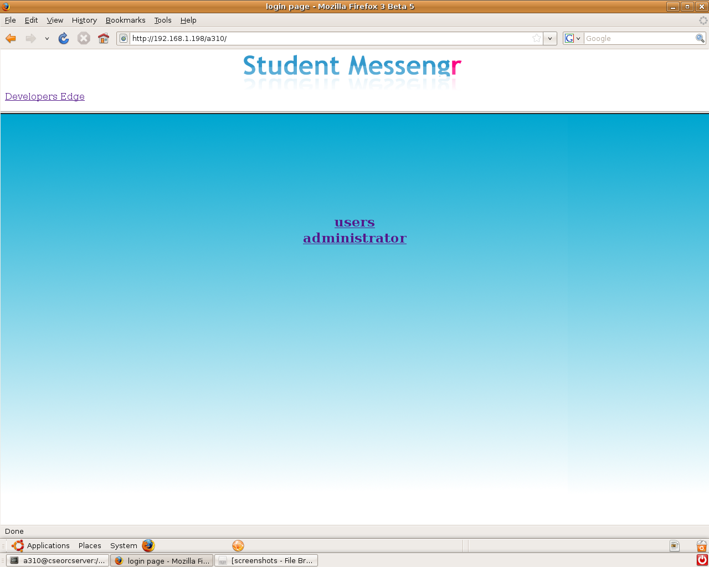

User login

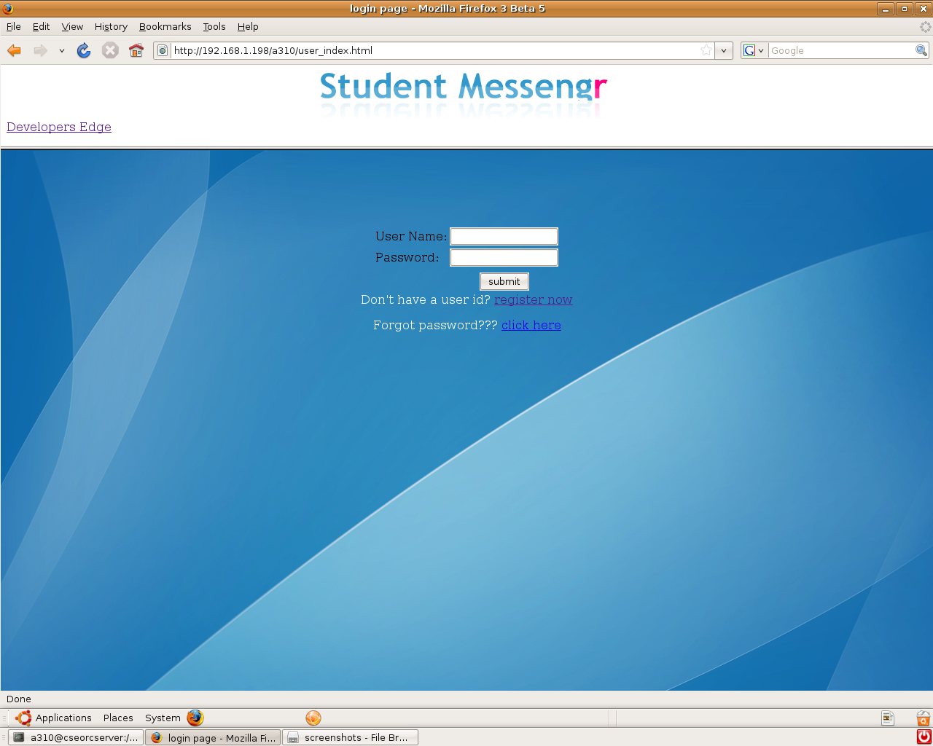

Registration

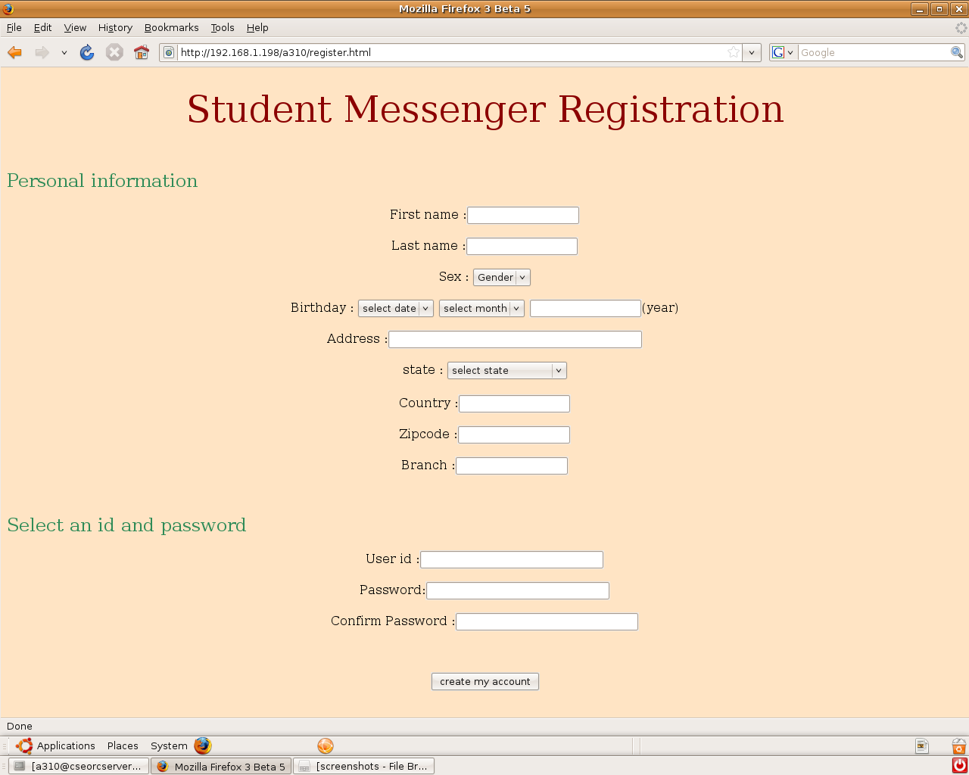

Compose mail

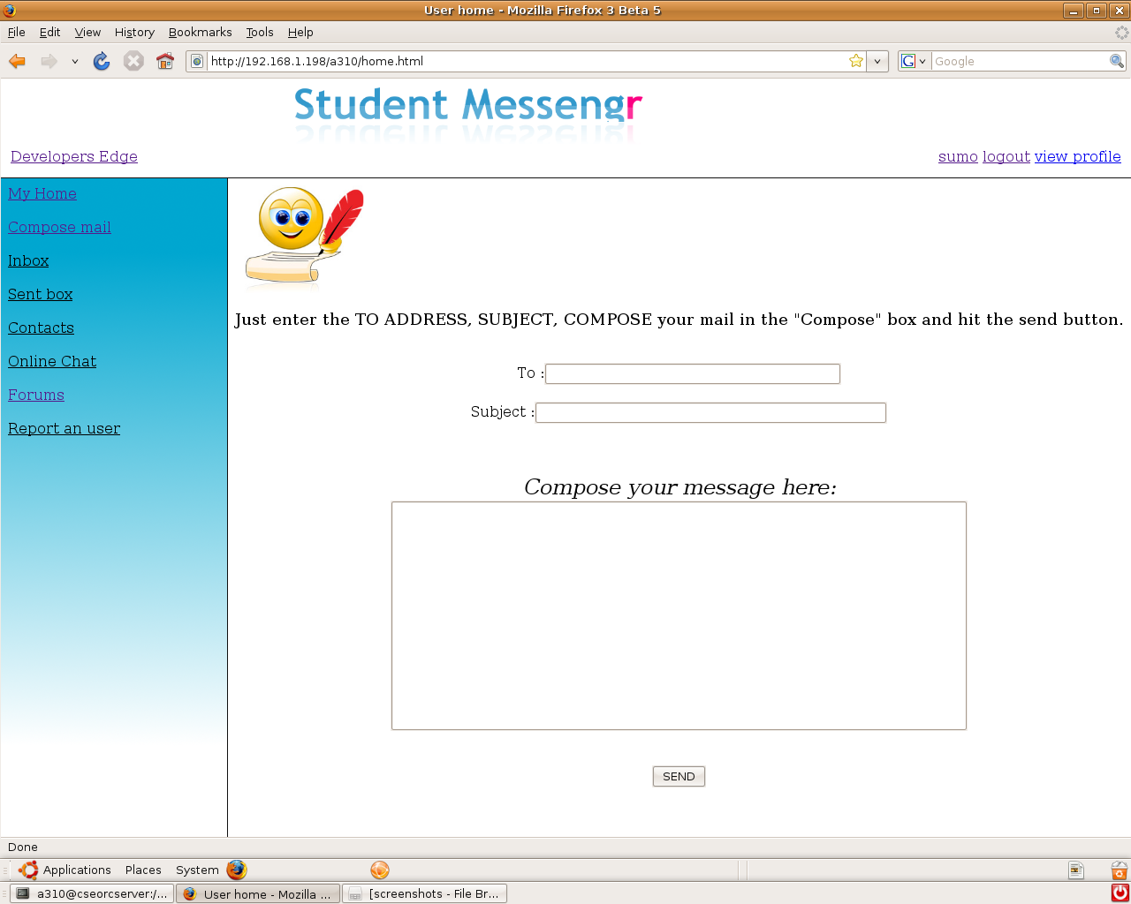

Contacts

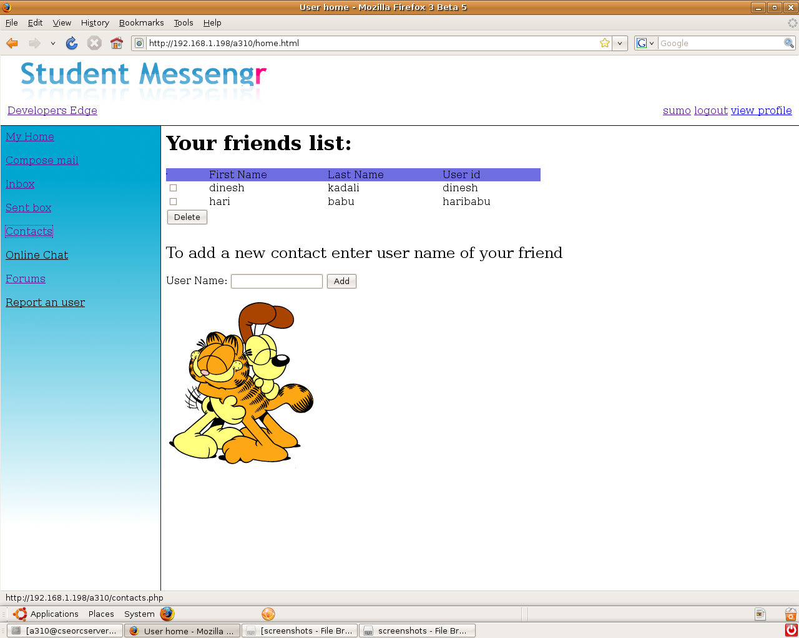

Online chat

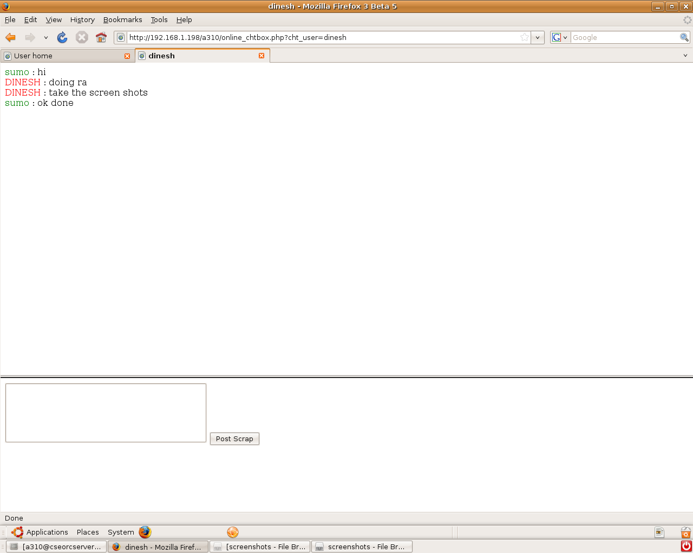

Admin Delete users

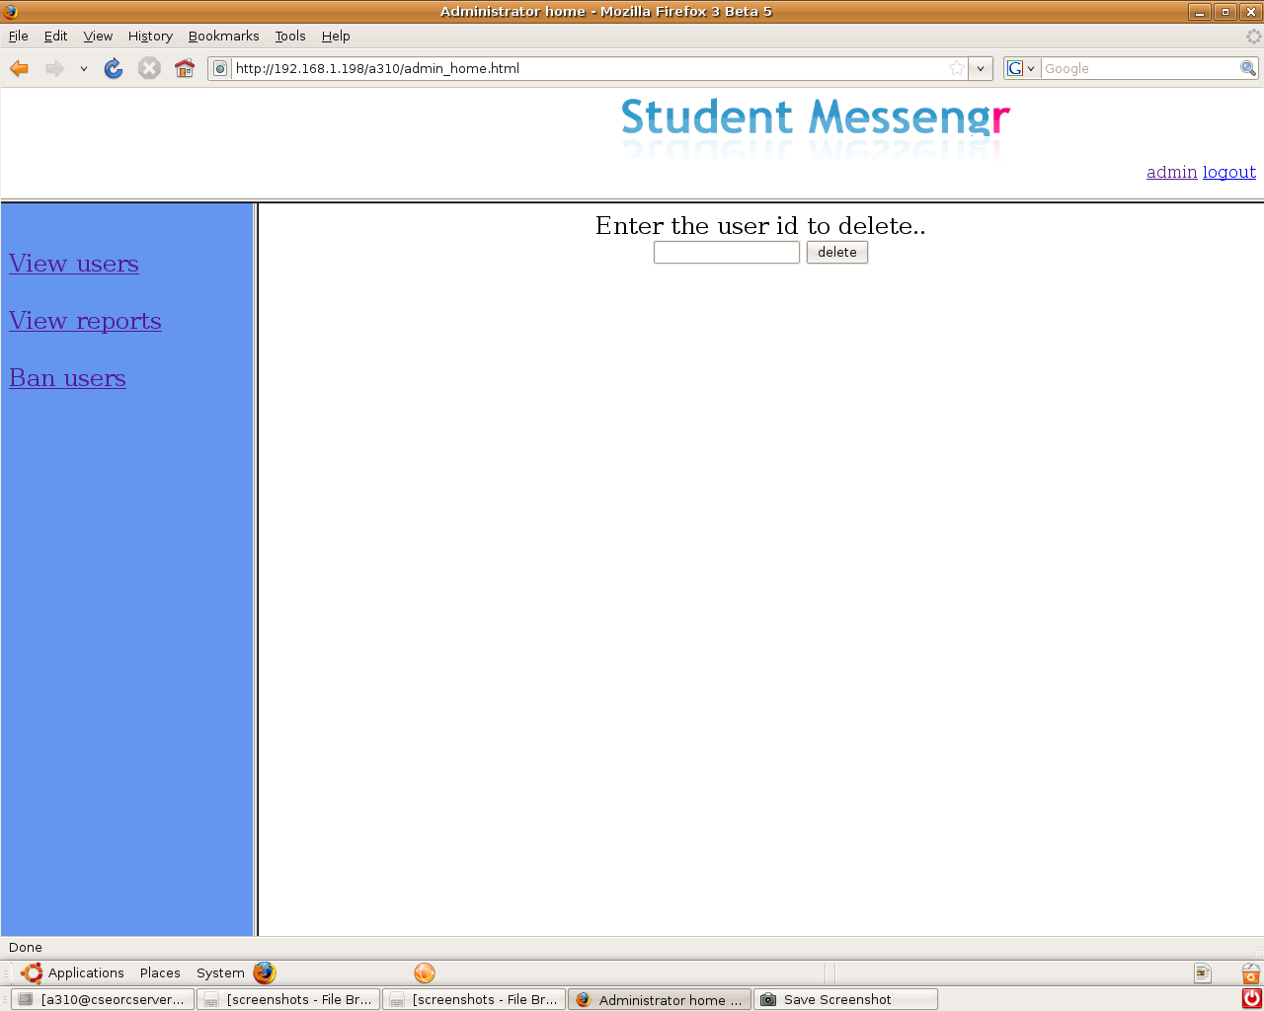

Inbox

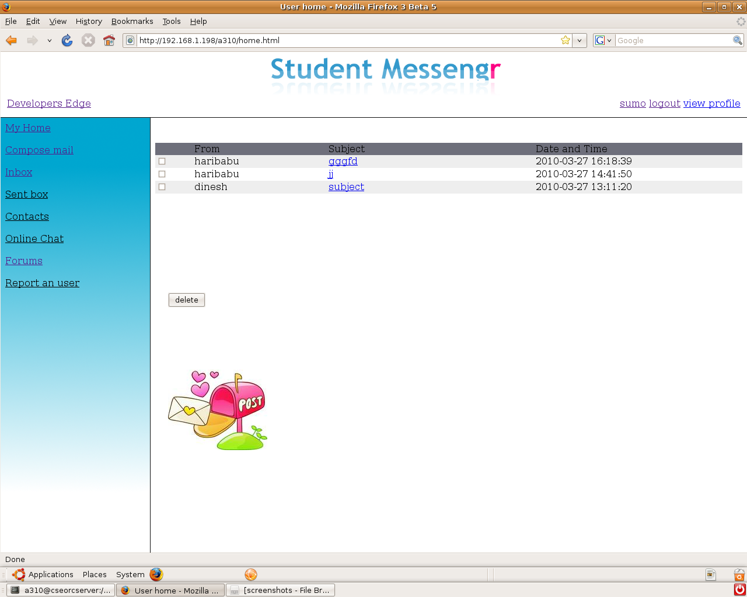

Online friends

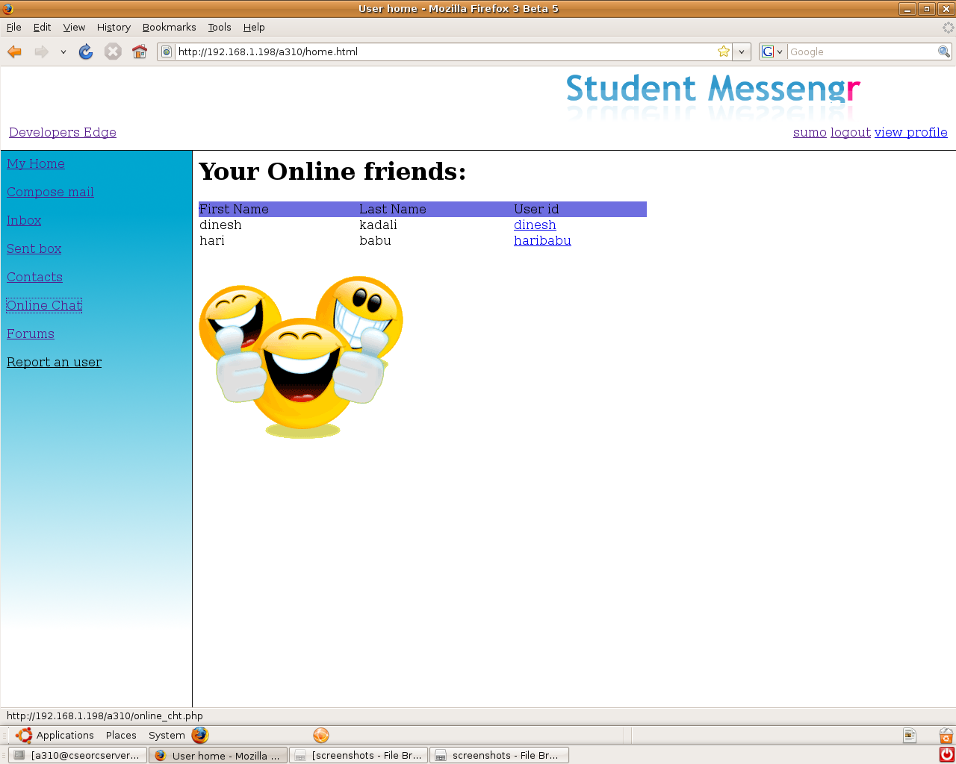

Forums

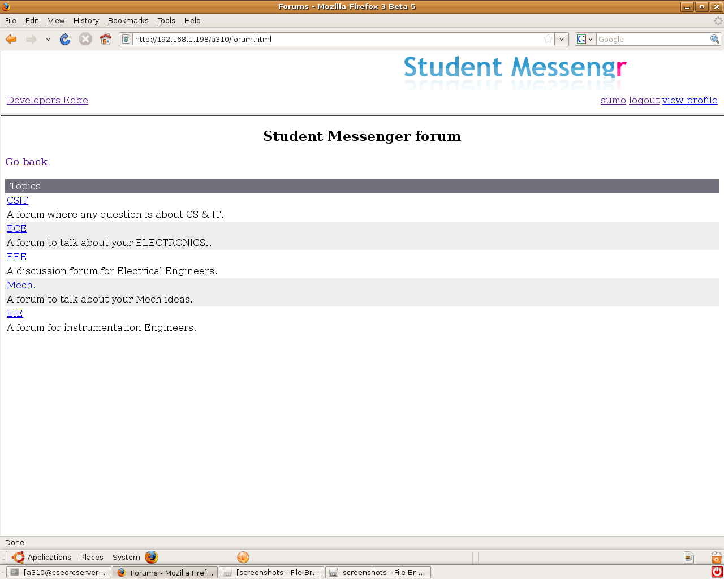

Forum posts

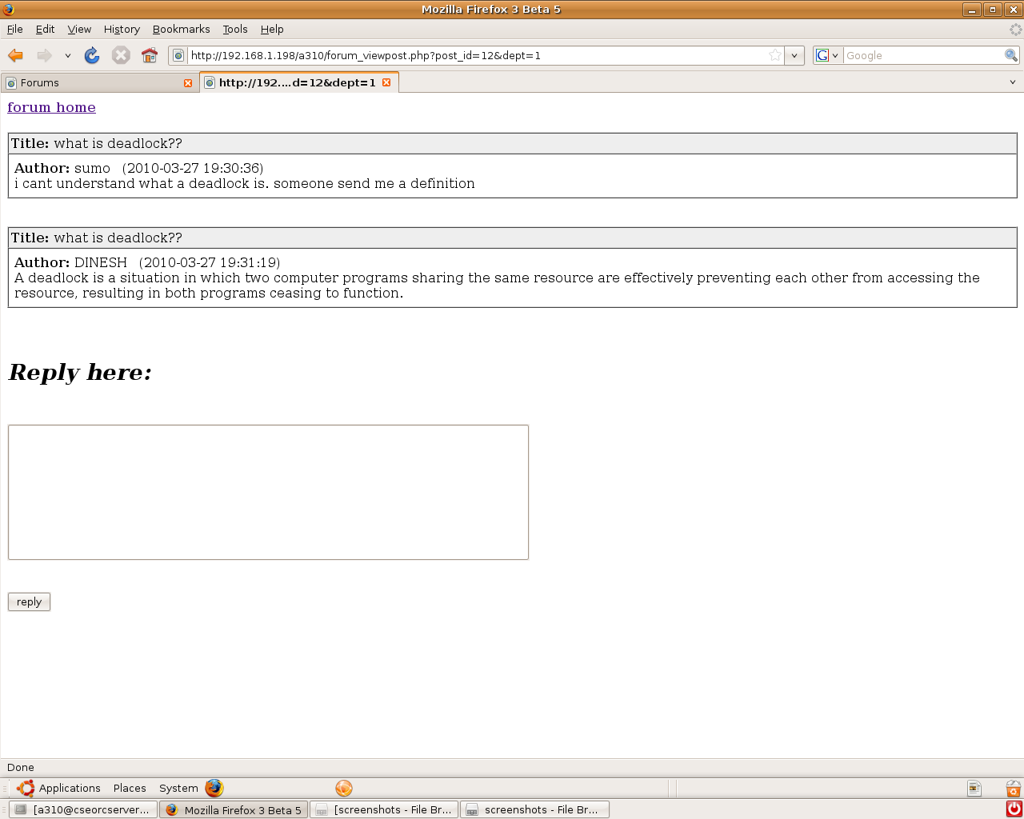

Users list

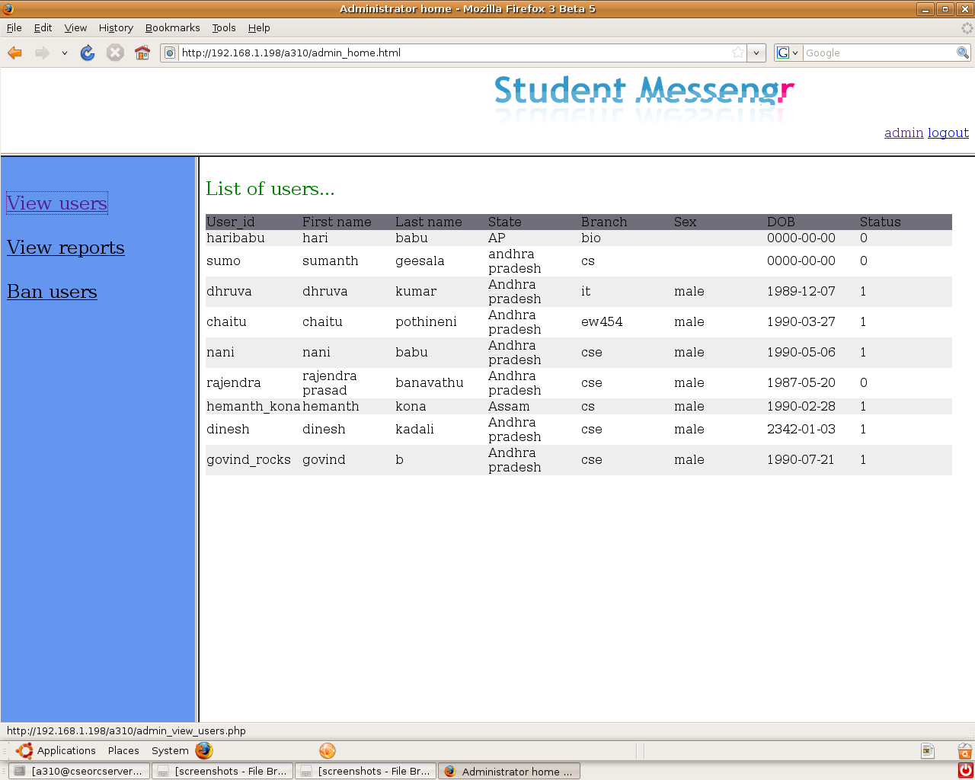

Reports

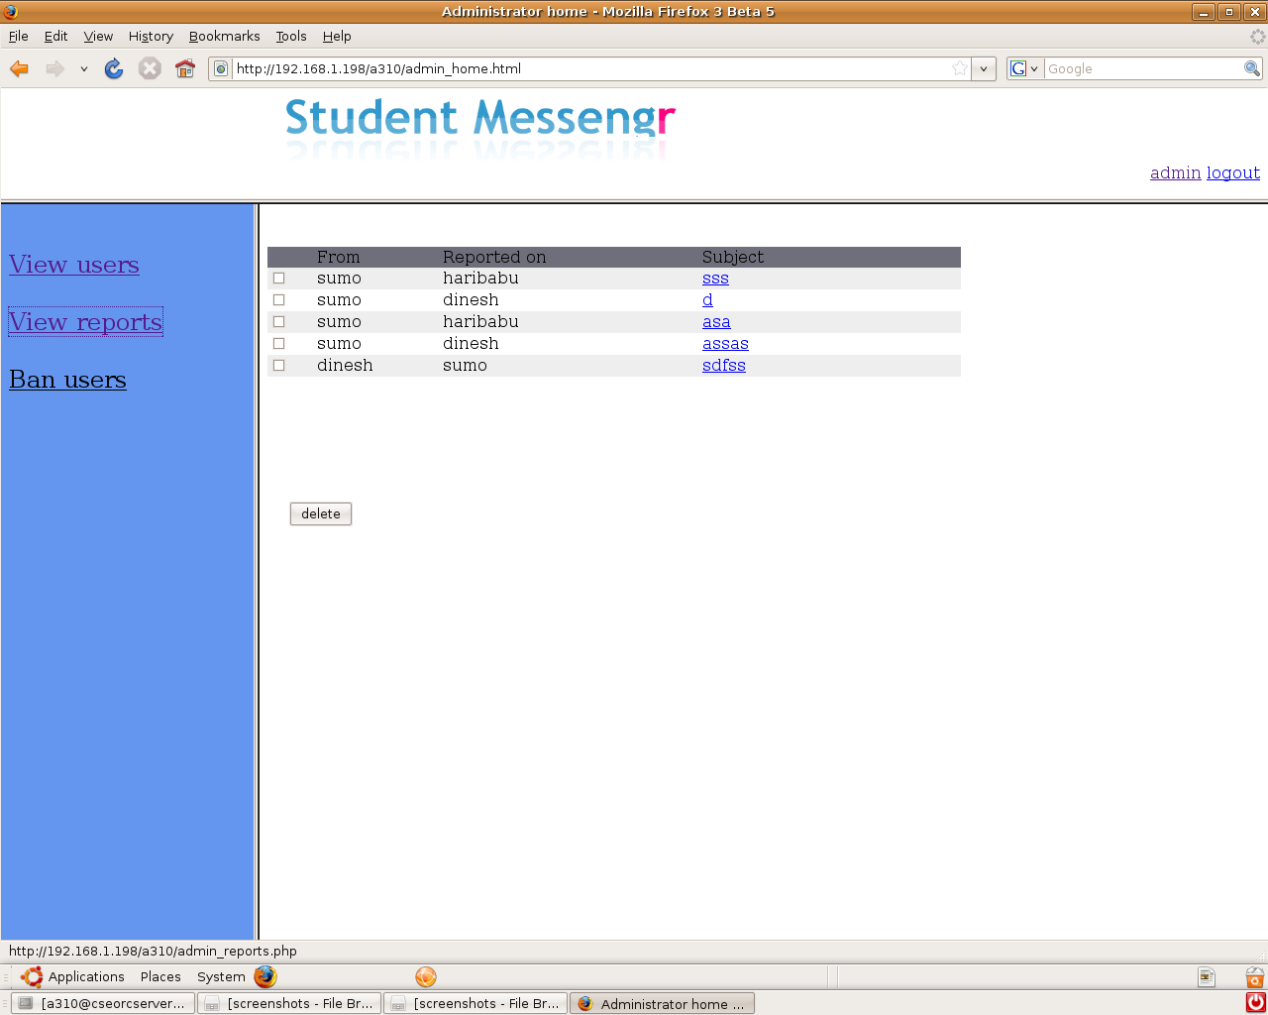

Delete users

8. CONCLUSION

The project “STUDENT MESSENGER” meets all the requirements of the communication for all students in a college campus . It meets as a centralized system; it provides student, friends, online friends, discussed questions in forums details.
The following functions are implemented successfully for this project.
- Retrieving, modifying student information.
- Retrieving, modifying the information of the student registered.
- Successful maintenance of online chat.
- Obtaining list of online friends.
- Successful maintenance of the permissions used.
- Successful maintenance of the list of infrastructure.
- Successful maintenance of the users by administrator.
- Provides high security for users by the concept “sessions”.

The future enhancement of this project is that this can be made online so that the students can use this STUDENT MESSENGER from anywhere in the world through internet.

9. BIBLIOGRAPHY

- HTML BLACK BOOK “Steven Holzner”
- “DATABASE MANAGEMENT SYSTEMS” Raghu Rama Krishnan Gehrke, McGraw-Hill Publications 3rd edition.
- “DATABASE SYSTEM CONCEPTS” 4th Edition, by Silberschatz, Korth, Sudarshan .,McGraw-Hill Publications
- Mysql Reference manual released by MySQLLAB corporation.
- PHP PROGRAMMING “Vikram Vaswani”
- PHP reference manual obtained from www.php.net
- HTML and PHP reference from www.w2schools.com

